IAMNano 2019 Düsseldorf
International Workshop on Advanced and In situ Microscopies of Functional Nanomaterials and Devices

October 27 – 30, 2019

Venue: Max-Planck-Institut für Eisenforschung,

Max-Planck-Str. 1, 40237 Düsseldorf, Germany
https://www.mpie.de/iamnano2019

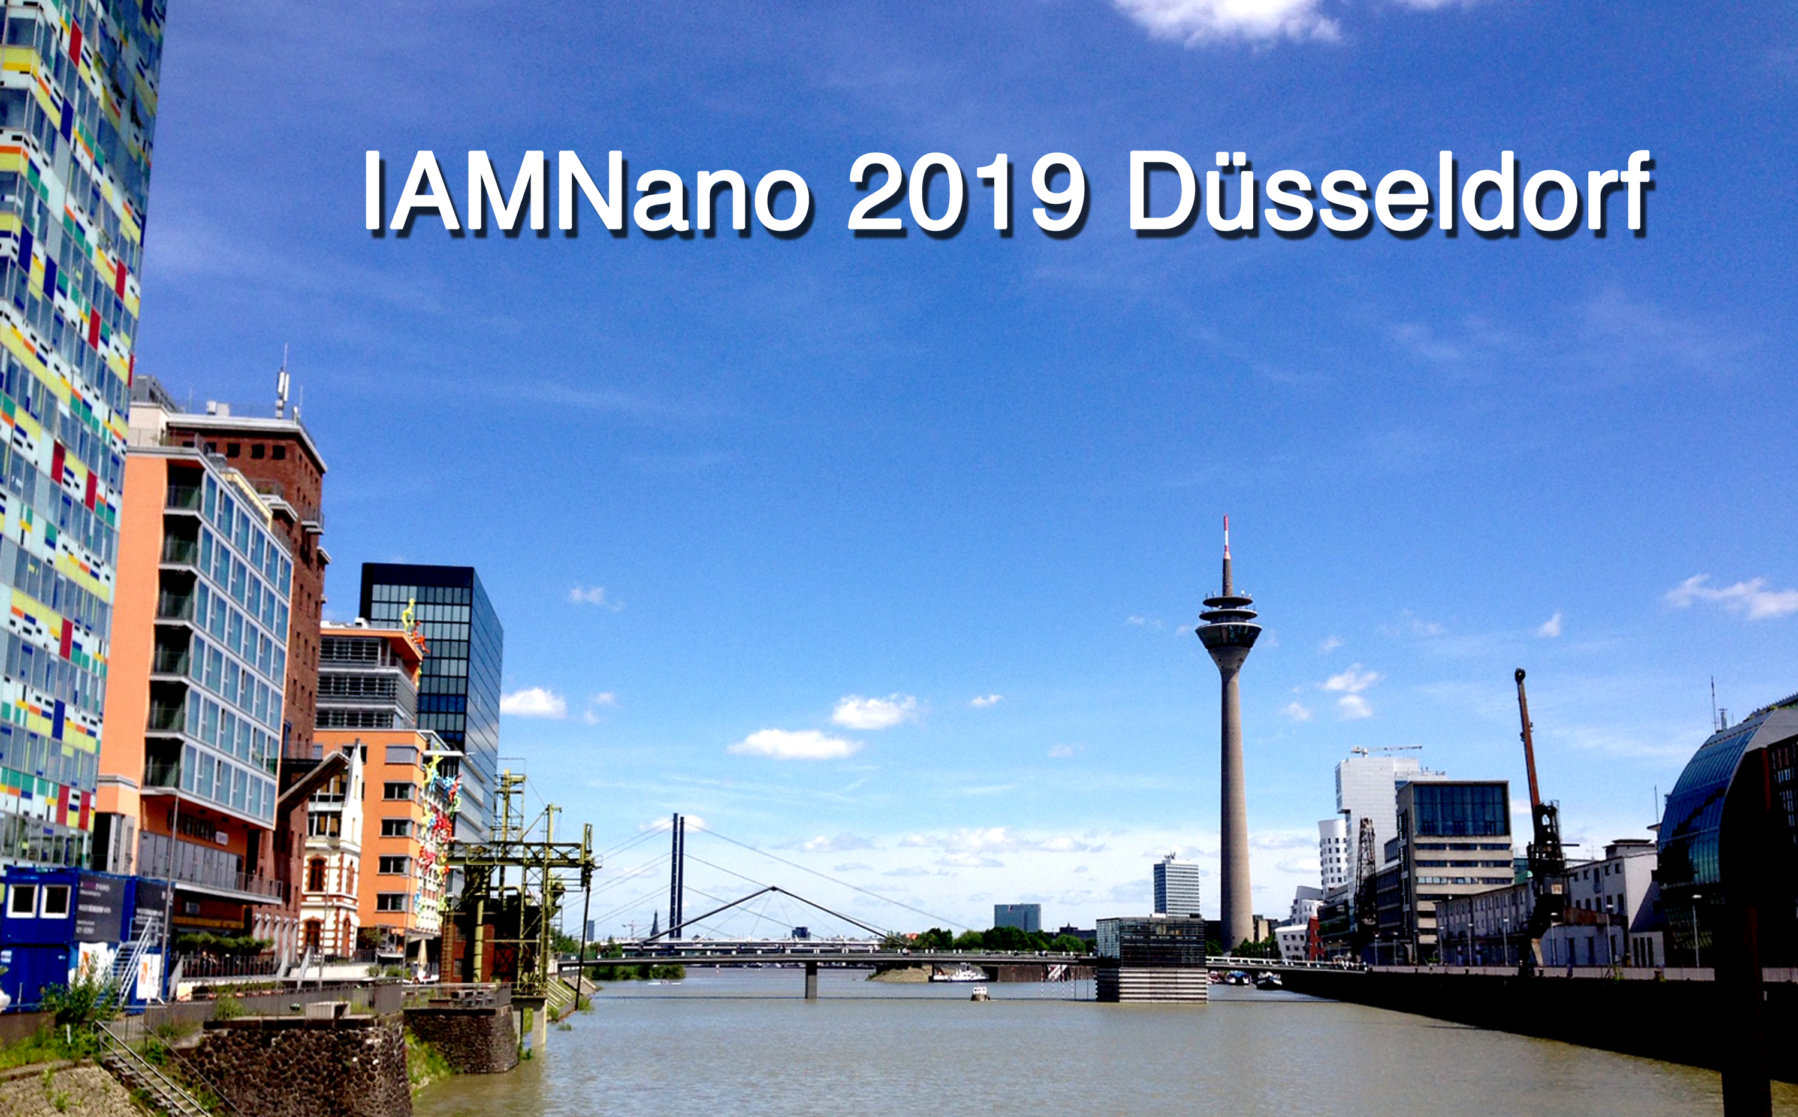

© Gerhard Dehm

Scope of the workshop
The workshop aims to provide a forum for researchers who are interested in applying advanced imaging and spectroscopy methods of electron microscopy, including aberration-corrected, in‐situ, environmental and low-voltage electron microscopy, to topical issues in materials science and engineering, in nanoscience, in soft matter research, in interface and surface science, and in biomaterials research. As these methods are of fundamental importance in virtually all technological fields, contributions are invited that address the broad spectrum of current materials research. Novel methodological developments will be discussed as well as topical areas of research on thin films, bulk materials, surfaces, materials at the nanoscale and at the interface between the physical and life sciences, for understanding structure‐property relationships of materials, as well as for metrology. Selected topics will be introduced by invited keynote speakers during the plenary sessions. A poster session provides room for the presentation and discussion of current research on
- New developments in aberration-corrected transmission electron microscopy (TEM) and scanning TEM (STEM)
- Advanced spectroscopy including energy dispersive X-ray spectroscopy (EDS) and electron energy loss spectroscopy (EELS)
- Electron holography and phase retrieval
- In situ and environmental TEM
- Computational microscopy and advanced data analysis
- Multiscale characterisation
- Materials for sustainable energy applications and mobility
- Advanced engineering materials
- Soft and biological materials

Local organizing committee Gerhard Dehm - MPIE Düsseldorf

(alphabetical order) Christian Liebscher - MPIE Düsseldorf

Christina Scheu - MPIE Düsseldorf / RWTH Aachen
Bernhard Völker - RWTH Aachen

Scientific Advisory Board Rafal Dunin-Borkowski - Ernst Ruska Center Jülich, Germany
(alphabetical order) Gunther Eggeler - Ruhr Universität Bochum, Germany
Wolfgang Jäger - CAU University of Kiel, Germany

Joachim Mayer - RWTH Aachen / FZ Jülich, Germany

Eva Olsson - Chalmers University, Sweden

Dierk Raabe - MPIE Düsseldorf, Germany

Jochen Schneider - RWTH Aachen, Germany

Robert Sinclair - Stanford University, USA

Contact information e-mail: iamnano2019@mpie.de

Preliminary Conference Program
___________________________________________________________________________
Oct 27 , 2019 SUNDAY 13.30 – 16.30 Registration
___________________________________________________________________________
13.30 – 16.30 Registration

14.15 – 14.30 OPENING REMARKS & WELCOME Chair

Opening Session POTENTIALS OF ABERRATION-CORRECTED (S)TEM Chair

14.30 – 15.00 Harald Rose (TU Darmstadt, Germany)
Minimum-dose phase-contrast tomography by numerical optical sectioning employing a Cc/Cs-corrected STEM and a pixelated detector

15.00 – 15.30 Max Haider (CEOS Heidelberg, Germany)
Advancement of high resolution Electron Microscopes

15.30 – 16.00 Ute Kaiser (Universität Ulm, Germany)
Understanding properties of low- dimensional materials by low voltage TEM

16.00 – 16.30 COFFEE BREAK

16.30 – 17.00 Kazu Suenaga (AIST Tsukuba, Japan):
Angular-resolved EELS of low-dimensional materials by means of low-voltage STEM

17.00 – 17.30 Joanne Etheridge (Monash University)
Tuning STEM: Tailoring the incident and scattered wave fields for optimum specimen information

17.30 – 18.00 Colin Ophus (Lawrence Berkeley National Laboratory, USA)
Phase reconstruction and simulation of STEM experiments in 2D and 3D using the scattering matrix formalism

18.00 – 18.30 Chunlin Jia (Xi’an University & FZ Jülich, China & Germany):
Quantitative HRTEM of functional oxides using negative Cs imaging

___________________________________________________________________________
Oct 28, 2018 MONDAY 08.30 – 10.00 Registration
___________________________________________________________________________
Session 1 ELECTRON HOLOGRAPHY, DPC, MAGNETIC STRUCTURES Chair

09.00 - 09.30 Christoph Koch (HU Berlin, Germany)
Computer-assisted imaging and spectroscopy in the TEM

09.30 - 10.00 Rafal Dunin-Borkowski (FZ Jülich, Germany)
Title to be announced

10.00 - 10.30 Jozef Zweck (University Regensburg)
Recent developments in imaging of magnetic and electric fields

16.00 – 16.30 COFFEE BREAK

Session 2 IN SITU AND ENVIRONMENTAL TEM Chair

11.00 - 11.30 Sang Ho Oh (Sungkyunkwan University, South Korea)
In-situ atomic-scale observation of polar surfaces of oxides at high temperatures

11.30 – 12.00 Eva Olsson (Chalmers University, Sweden):
In situ studies of electrical and optical properties of Quantum Devices

12.00 – 12.30 Robert Sinclair (Stanford University, USA)
The influence of electrochemical testing on the structure of oxide, sulphide and nitride thin films, and prospects for in situ studies

12.30 – 13.30 LUNCH BREAK & DISCUSSIONS

Session 3 STRUCTURAL MATERIALS & MECHANICAL PROPERTIES Chair

13.30 – 14.00 Hamish L. Fraser (Ohio State University, USA)
Nanoscale structural instabilities in metastable beta titanium alloys and their role in providing both strengthening and low elastic modulus

14.00 – 14.30 Guillaume Laplanche (Ruhr Univeristät Bochum, Germany)
TEM investigations of microstructural evolution during tensile deformation of high- and medium-entropy alloys
14.30 – 15.00 Christoph Kirchlechner (MPI Eisenforschung, Germany)
Twin boundaries: obstacles for or sources of dislocations

15.00 – 15.30 Bernhard Völker (RWTH Aachen, Germany)
In-situ SEM study of the fracture behaviour of Cr₂AlC coatings

15.30 – 16.00 COFFEE BREAK

Session 4 BIOMATERIALS AND SOFT MATTER
Chair

16.00 – 16.30 Jürgen Plitzko (MPI Biochemie Martinried, Germany)
In situ structural biology - Cryo-electron tomography of cells and tissue at molecular detail

16.30 – 17.00 Martin Müller (Helmholtz-Zentrum Geesthacht, Germany)
Title to be announced

17.00 – 17.30 Fu-Rong Chen (City University Hong Kong, China)
Toward atomic resolution dynamics for soft materials

17.30 – 18.30 Selected contributed presentations Chair
18.30 – 20.30 Poster Session - contributed posters
GET TOGETHER

___________________________________________________________________________
Oct 29, 2018 TUESDAY 08.30 – 10.00 Registration
___________________________________________________________________________
Session 5 STEM IMAGING AND ANALYSIS
Chair

09.00 – 09.30 Andreas Rosenauer (Universität Bremen, Germany):
ISTEM - theory and practice

09.30 – 10.00 Haijun Wu (National University Singapore, Singapore)
STEM analysis of thermoelectrics and piezoelectrics

10.00 – 10.30 Dagmar Gerthsen (KIT Karlsruhe, Germany)
STEM, FIB-SEM and EDXS tomography of solid oxide fuel cells

10.00 – 10.30 COFFEE BREAK & DISCUSSIONS

Session 6 MATERIALS FOR ENERGY APPLICATION
Chair

11.00 – 11.30 Kerstin Volz (Universität Marburg, Germany)
4D-STEM for energy materials

11.30 – 12.00 Elena Tchernychova (National Institute of Chemistry, Slovenia)
Title to be announced

12.00 – 12.30 Thomas Klassen (Helmut-Schmidt-Universität Hamburg, Germany)
Nanostructured photoactive coatings for solar water splitting

12.30 – 13.30 LUNCH BREAK

Session 7 SPECTROSCOPY Chair

13.30 – 14.00 Gianlugi Botton (Canadian Light Source, University of Saskatchewan and Canadian Centre for Electron Microscopy, McMaster University, Canada)
Using electrons and photons for materials characterization: where do we think we stand?

14.00 – 14.30 Simon Ringer (University of Sydney, Australia) to be confirmed
Title to be announced

14.30 – 15.00 Mathieu Kociak (Laboratoire de Physique des Solides, France)
Advances in high resolution electron spectroscopies: EELS, EEGS and CL

15.00 – 15.30 Quentin Ramasse (SuperSTEM, UK)
Monochromated electron energy loss spectroscopy at high spatial resolution

15.00 – 15.30 COFFEE BREAK

Session 8 CORRELATIVE MICROSCOPY & ATOM PROBE TOMOGRAPHY Chair

16.00 – 16.30 Julie Cairney (University of Sydney, Australia)
Extreme room temperature deformability in ferroelectric oxide pillars

16.30 – 17.00 Christian Liebscher (MPI Eisenforschung, Germany)
Grain boundary phase transitions in metallic materials

17.00 – 17.30 Williams Lefebvre (University Rouen, France)
Title to be announced

17.30 – 18.00 Thomas Kelley (Amatek, USA)
Project Tomo: Atom Probe and TEM to Be Combined at Last

19:30 CONFERENCE DINNER

___________________________________________________________________________
Oct 30, 2018 WEDNESDAY 08.30 – 10.00 Registration
___________________________________________________________________________________________
Session 9 ADVANCED MATERIALS 1 - ALLOYS & STEELS Chair

09.00 – 09.30 Joachim Mayer (RWTH Aachen, Germany)
White etching areas - the mistery of premature bearing failures

09.30 – 10.00 Stefanie Sandlöbes (RWTH Aachen, Germany)
Title to be announced

10.00 – 10.30 Sophie Primig (UNSW Sydeny, Australia)
Microstructure control during advanced manufacturing

10.00 – 10.30 COFFEE BREAK

Session 10 INTERFACES AND NANOSTRUCTURES
Chair

10.30 – 11.00 Uli Dahmen (Lawrence Berkeley National Laboratory, USA)
Observations on the structure of the Ag-Ni interface

11.00 – 11.30 Sandra van Aert (University of Antwerp, Belgium):
3D atomic scale quantification of nanostructures and their dynamics using model-based STEM

11.30 – 12.00 Damien Alloyeau (University Paris, France):
Reveal the behavior of nanomaterials in their formation and application media with a TEM

12.00 – 12.30 Patricia Kooyman (University of Cape Town, South Africa)
Development of operando gas-phase TEM and applications in catalysis research

12.30 – 13.30 LUNCH BREAK & DISCUSSIONS

Session 11 INTERFACES AND NANOSTRUCTURES II Chair
13.30 – 14.00 Heike Gabrisch (Helmholtz-Zentrum Geesthacht, Germany)
Microstructural evolution within alpha2 lamellae of a gamma-TiAl alloy

14.00 – 14.30 Grace Burke (University of Manchester)
Title to be announced

14.30 – 15.00 Erdmann Spiecker (Universität Erlangen-Nürnberg, Germany)
In situ electron microscopy of nanomaterials in SEM and TEM: New approaches and applications

15.00 – 15.30 Wolfgang Jäger (Universität Kiel, Germany)
Growth and defect phenomena in heteroepitaxial CVD diamond for magnetometry and quantum science

CONCLUDING REMARKS, COFFEE & FAREWELL

END OF WORKSHOP

